- About us – It is ok
- Events – change as below
- Our Team – Change as bel0w
- Join us – Change as below
- Contacts - It is ok

Events
A variety of cutting-edge research projects are currently being conducted by researchers affiliated with the Interfaith Panel for a Living Planet. The research initiative seeks to generate tangible and sustainable solutions to worldwide problems by deepening understanding in providing evidence based information across stakeholders.

Upcoming Events (Virtual seminars)

- July 22nd 2022, 2000 hrs EAT: How Regions Actors Respond to COVID-19.

- August 26th 2022, 1600 hrs EAT: Climate Related Decision Making. Making room for religious and local actors, including women and children and vulnerable group in climate related planning policy making and implementation.

- October 7th 2022, 1700 hrs EAT: The Practice of Religious Toleration in Past and Contemporary African.

- September 23rd 2022, 2100 hrs EAT: Villas to Villages: Religious Networks Fight Corruption at all Levels, Getting religious networks and governments to bring focus on positive change for the people.

- October 13th 2022, 1800 hrs EAT: Religious Organizations’ Safeguard the Environment through Cooperation.

- November 16th 2022, 2000 hrs EAT: Faith Sensitive Approaches for Children on the Move brings them Closer to Well-being.

- December 9th 2022, 1600 hrs EAT: First Equity, then Sustainability: There is hope to save the Earth when we put ourselves in the centre of change.

- January 22nd 2023, 1900 hrs: Prayers and Policy: How Governments and Religious Actors can meet Sustainable Development Goals together.

Our Team .

REOMOVE

John E. Wasige, PhD:

Member and the Themes Committee Team Leader
Busitema University, Uganda
Add “Board” to read “IRePliP Board Member”

Join us – ADD AS BELOW

IRePliP is open to individuals, associations, institutions, publishers, journals, media and organizations engaged to provide evidence based decision making.

Partners – ADD AS BELOW AND INSERT THE PARTNERS LOGOS ONLY

The panel share expertise and materials as well as diverse approaches to studies within a larger and more comprehensive framework. This provides the basis for the creation of a permanent research infrastructure for decision making to transform our world through SDGs, Country’s action Agendas and Religious initiatives.

Decision makers and scientists need to establish the expanding evidence base on the relationship decision and research. At IRePLiP, we bring together scientists, decision makers and other various players to handle this critical area.

IRePLiP aims to constitute an inclusive network, to act as an open platform, and to provide a framework to foster research, communication, exchange and cooperation concerning important issues for the global world and society at large. Our partners are;

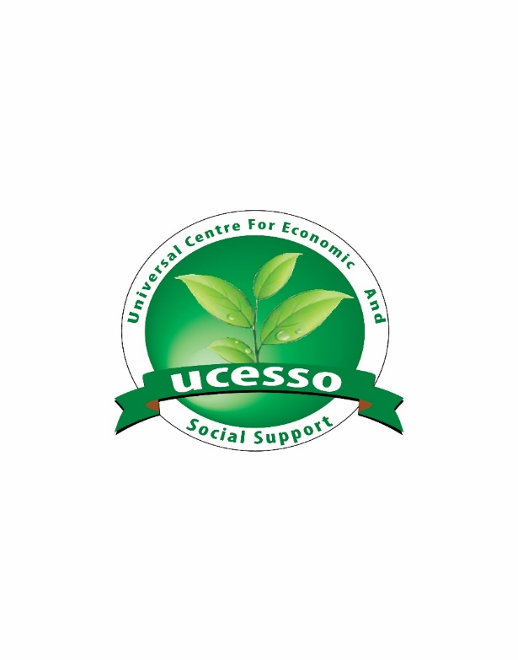



OTHERS
- Use appealing font size and type.
- Have the headings in bold BUT not in capital letters.
- Align heading with the paragraphs to look aligned, see various website

